Name_____________________________________________ Lesson 11 Activity
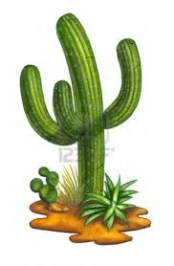
Use your knowledge of Greek and Latin roots and your dictionary to figure out the words hinted at below.
- –i (plural)
the name of the twins in the zodiac________________________________
male graduates of a school________________________________
(technically female graduates have an ae at the end of the word)
those three guys who visited the baby in Bethlehem________________________________
those prickly plants that grow in the desert________________________________
those eight-legged creatures in the sea________________________________
the plural of fungus________________________________
the plural of focus________________________________

- jus/jud (law)
what the courts hand down________________________________
the legal system is called the ________________________________ system
when something is fair and right, it is considered to be ________________________________

- lum (light)
the moon and the stars are ________________________________
the types of manuscripts the monks produced in the Medieval era_____________________________
the metal made of bauxite________________________________

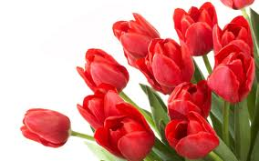
- ann/enn (year)
married folks celebrate these________________________________
flowers that bloom every year _______________________________
book you get at the end of the school year ________________________________
a type of tax-free savings________________________________

- apo (away)
Matthew, Mark, Luke and John who went “away” and spread the word_________________________
the opposite of perigee; the farthest point of the moon’s orbit from the sun_____________________

- sen (old)
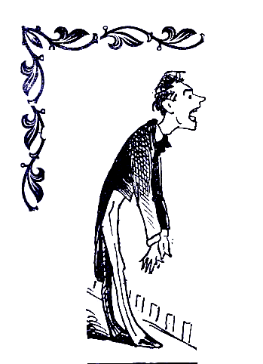
what really old folks might seem on occasion________________________________
the folks we elect to represent us in Congress ________________________________
the oldest group of students in high school or college ________________________________

- sol (alone)
what a single singer sings________________________________
Shakespeare has his characters give these to reveal their inner thoughts________________________
(“Romeo, Romeo, wherefore art thou, Romeo?” said Juliet on her balcony)
hermits like ________________________________ as they like to be alone
bad prisoners sometimes spend time in ________________________________ confinement
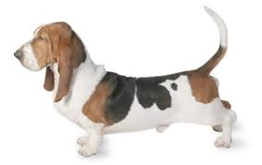
- bas (low)
a “low” guitar is a ________________________________
another instrument that plays low is the ________________________________
a baby might stay in a ____________________________, which is low to the ground
a type of hound dog that is low to the ground ________________________
the most fundamental level of skills is known as the ________________________________ “Bassett hound.”
Dogtime Network.
Dogtime Meda.com. 25
- rogat (ask) June 2014.
when the police question you, this is an ________________________________
negative or ________________________________ comments can be hurtful

- parl (speak)
where our British counterparts make laws ________________________________
an old-fashioned room where suitors wooed young ladies________________________________

- potent (power)
all powerful ________________________________
the challenge for teachers is to help students reach their ________________________________
a monarch, a ruler, one who has power is known as a ________________________________

- surg (rise)
computers need _____________________________protectors to protect them from a rise in power
when something rises again, like a fashion trend, it is a ________________________________
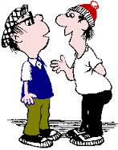
when people rise up against something, it is an ________________________________

- log (word/reason)
Mathematicians are usually very ________________________________.
“new” + word = ________________________________
when something is not reasonable, it is considered ________________________________
an actor might give one onstage, and it technically means “one word” _________________________
two people or actors in a conversation use________________________________

- gram (writing)
a message or writing that someone receives from far away________________________________
“five” + “writing”; a five-pointed star ________________________________
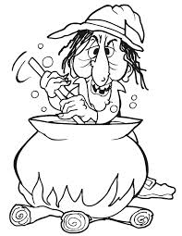
some credit cards are illustrated with these pictures that change as you move them____________________
rules of a language and its writing and speaking________________________________

- cant (sing)
what witches chant or sing over their cauldron________________________________
when you take back what you said, technically it means to sing again
________________________________

Choose the set of words with the same relationship as the given boldfaced words. It is best to form a sentence that shows the logic of the analogy.

Example: hand : glove :: foot : shoe

“A hand goes in a glove like a foot goes in a shoe.” Hand and foot are body parts; glove and shoe are accessories.

- telegram : pentagram ::
solidian : desolate
epistle : parallelogram
solitude : solitary
apotheosis : renunciation

- alumnus : alumni ::
cantata : canticle
luminous : superluminous
phenomenon : phenomena
mobilize : immobile

- base : abase ::
prolific : soporific
mobile : immobile
parley : parliament
fortification : fortify

- soliloquy : alone ::
dialogue : partner
conversation : quiet
argument : solo
dream : sleep

Write sentences using the following words. If possible, make them relate to the piece of literature you are currently reading for English class.
foci_____________________________________________________________________________________________________________________________________________________________________________
justice___________________________________________________________________________________________________________________________________________________________________________
luminescent______________________________________________________________________________________________________________________________________________________________________
interrogate_______________________________________________________________________________________________________________________________________________________________________
potent__________________________________________________________________________________________________________________________________________________________________________
logical___________________________________________________________________________________________________________________________________________________________________________

